BWLogo_SMALL

**STEERING**

Dr. Nicole Anderson

Syrelle Bernstein

Laura Stefanik

Sarah Charney

Dr. Tony Fattal

Elaine Harris

Alan Marks

Janice Maser

Lesley Miller

**VDQ**

Dr. Nicole Anderson

Dr. Edeltraut Kröger

Dr. Deirdre Dawson

Dr. Laura Wagner

Susan Dane

Denise Goldstein

Susan Taerk

Wendy Weber

**November 2012**



**New Horizons for Seniors Program**

**VOLUNTEER SERVICES**

Syrelle Bernstein, Director

Raquel Heayn, Assistant

**RESEARCH**

Dr. Nicole Anderson Dr. Malcolm Binns

Dr. Deirdre Dawson Dr. Thecla Damianakis

Dr. Laura Wagner Dr. Edeltraut Kroger

Laura Stefanik, Assistant

Roshan Guna, Participant Coordinator

**MARKETING**

Syrelle Bernstein

Zel Bocknek

Dr. Tony Fattal

Elaine Harris

Alan Marks

Janice Maser

Lesley Miller

**INTERVIEWERS**

Beverley Abosh

Dr. Elaine Cooper

Janice Babins

Elaine Fattal

Janet Finkelstein

Anne Katz

Alan Marks

Dr. Rachel Schlesinger

Wendy Weber

**TESTERS**

Janice Babins

Kaselle Beach

Marilyn Boltman

Susan Dane

Janet Finkelstein

Judy Gliserman

Denise Goldstein

Elaine Harris

Carole Jones

Anne Katz

Joe Leinwand

Fauna Lidsky

Lorna MacGregor

Didi Marks

Clare Markus

Bina Maserזײל

Judith Plaut

Nancy Posluns

Wendy Weber

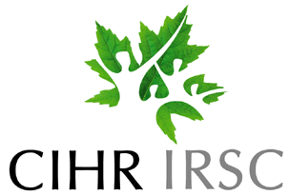

**ALUMNI**

Eilon Caspi

Suzanne Cook

Marie Goodman

Anita Lapidus

Linda Redhill

Paula Silver